Filtering Process:
Orig_trim_fast_file.py

Creating oligo templates:
indelmap_combined_initial.py
update_cut_site_number.py
sorting_indelmap_SRR3709999.py

Mapping the reads to template:
indelmap_combined.py
Producing summary file:
create_summary_after_null_mapping.py
adding_percent_summary_file.py
create_all_guides_files.py

Deletions:
left_right_distributions_from_indels_condensed.py
deletions_no_repeats_positions_and_lengths.py

Microhomologies:
all_indel_microhomology_run.py
deletions_repeats_all_positions_and_lengths.py

Insertions:
example_reads_for_indel.py
output_insertions.py
plot_insertions.py

Other plots:
mean_read_number.py
indel_frequency_vs_read_count.py
indel_lengths.py UPDATE

The deep sequencing data used in the analysis was available under the accession code SRP071322 and used those with accession number SRR370999 and SRR3710048.

Filtering process:

Orig_trim_fast_file.py
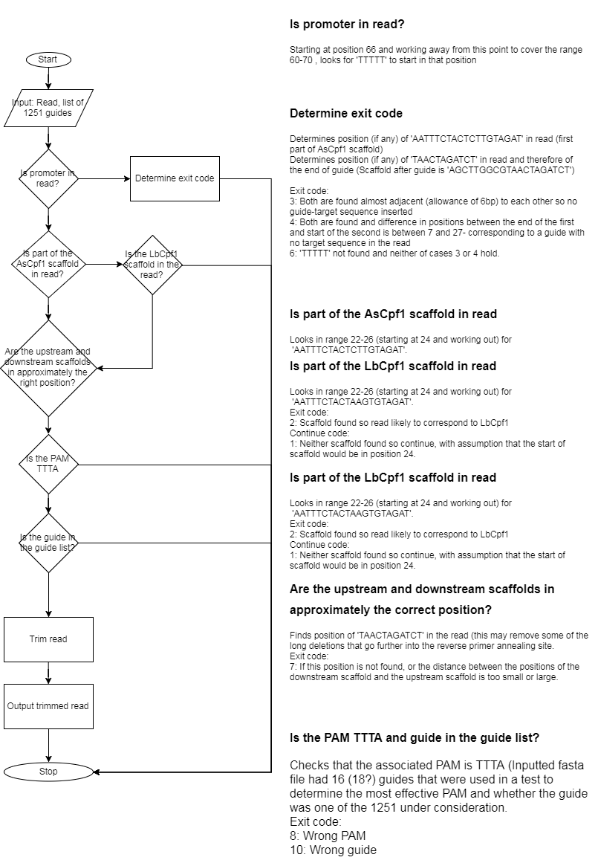
Inputs: Fasta files from either SRR3709999 or SRR3710048. The fasta files contain 1 000 000 reads by default.
Guide list
Outputs: Fastq files with the trimmed reads corresponding to guides in the guide list
Notes: Improvements to the filtering process could be made, especially in the section ‘Are the upstream and downstream scaffolds in approximately the correct position’, where ‘TAACTAGATCT’ could be truncated slightly on the left when looking for a match. Also, the PAM is required to be TTTA. Both of these may bias against some of the longer deletions as reads corresponding to these would not have been included in the filtered file. It might have been a better approach to initially filter the fastq files by guide and then checking that the read was in the right format.

Creating template:

indelmap_combined_initial.py
Runs the indelmap program on the filtered trimmed fastq files from the data set SRR3709999 with parameters 1 (with position of the guide 7-30) and 5, for the variation in the position of the cut site.
Inputs: indelmap.exe Path to this program
guide_index.txt Text file with 7 30
Directory with SRR3709999 fastq files 20 trimmed fastq files with reads from SRR370999
orig_oligo_template.fasta Template oligo file for 1251 guides with their barcodes
Output directory
Outputs: {}_mapped.txt 20 text files with the oligo that each read mapped to.
This should also be run on the trimmed fastq files from SRR3710048, with the same parameters to enable the reads to be separated according to the corresponding guide.

update_cut_site_number.py
3 functions with update_cut_site_number taking an oligo indel and mutation and returning the modified cut site number.
Inputs: indel and mutation
Outputs: updated cut-site position for template file

sorting_indelmap_SRR3709999.py
From the output of mapping the reads in the SRR3709999 data set to the 1251 guides, examples of each of the indels and mutations in the library are found, along with the percentage that they occur. Template files for each of the guides including these mutations are found with corrected cut sites.
Inputs: {}_mapped.txt
SRR3709999 fastq files
Outputs: {}.fasta Template files for each of the guides.
100 gave an empty file after running this script so manually gave it the original template.

Mapping the reads to template:
Although, I’m not sure on the best tolerance value for the max_cut_dist, relaxing it to 8 with the cut site is after the 18th nucleotide in the target means that D1 L-11R-9 occurs 0.29% of the time, where for comparison the most frequent indel of D6 L-6R1 occurs 0.30% of the time.

indelmap_combined.py
Runs the indelmap program on the trimmed fastq files from the data set SRR3710048, separated by guide number, with parameters 0 (with position of the guide 7-30) and 5 for the variation in the position of the cut site.
Inputs: indelmap.exe Path to this program
guide_index.txt Text file with 7 30
SRR3710048 fastq files separated by guide
Outputs: 1251 indelmap output files

Producing summary file:

create_summary_after_null_mapping.py
Generates the summary file from the 1251 indelmap output files. When a read is mapped to multiple oligo files, one is selected randomly out of suitable matches.
Inputs: base_dir Directory to store output files
1251 mapped files Path to indelmap output files for guide numbers 1 to 1251
Outputs: summary_file.txt Summary file of indels for each of the guides with the count of the number of reads with that indel.
@@@Cpf1_Oligo3
D2_L2I2R5 -_- 1
D4_L-9I4C11R3 -_D1S-46 1
- -_M-74 1
- -_- 45
- -_D1S-46M-72 13
- -_M-12 1
- D1_L0I1R2_D1S-46 1
- -_D1S-46 3

adding_percent_summary_file.py
Computes the percentage of times that each indel occurred for each guide and outputs the summary indels file with an extra column with this percentage.
Inputs: summary_file.txt Path to the summary file
Outputs: summary_indels_percent.txt Path to the outputted summary file with the percentages included

create_all_guides_files.py
From the summary
Inputs: base_dir Base directory to store the output files. Should include the “core_files” folder containing the “'nmeth.4104-f3.txt” file and “summary_file.txt” file, created from running ‘create_summary_after_null_mapping.py’
Outputs: all_guides.txt
guide number guide sequence read count reported
4 AACCTCGTCCGCCACGACTACCG 626
all_guides_freq.txt
guide number guide sequence read count reported indel frequency
4 AACCTCGTCCGCCACGACTACCG 626 0

Deletions:

left_right_distributions_from_indels_condensed.py
Produces a heat map showing the left and right positions of each deletion, when there is no ambiguity or microhomology associated. Also produces heat maps for each of the separate activity groups.
Inputs: summary_file_percent.txt Path to this file
base_dir Base directory where all output is stored. Should contain the indels_associated_condensed.txt file created from running all_indel_microhomology_run.py.
all_guides (optional) 0 to plot heat map for all guide, 1 to not default = 1
separate_activity_groups (optional) 0 to produce heat map with the distribution for 5 separate activity groups, 1 to not, default = 1
cumulative_activity_groups (optional) 0 to produce heat map for the cumulative distribution with increasing guide activity, 1 to not, default = 1
filter (optional) Lower limit on read count to consider the guide in the plots, default = 100
Outputs: heat_left_v_right_* * depends on which options were selected
Plots expected:
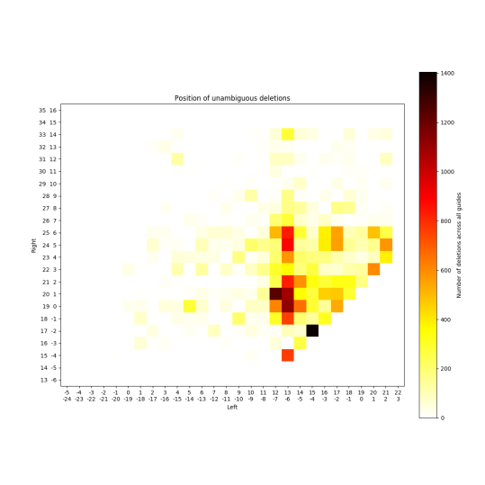

deletions_no_repeats_positions_and_lengths.py
Considers only the deletions which have no microhomology or repeat associated with them, finds the length of the deletion together with the positions of the left and right edges of the deletion (the last position where the template and the read match – as given in indel from summary file). This script can also choose a left and right position independently from the found distributions and compute the deletion length and plots:
- Profile of deletion lengths
- Profiles of the left and right ends of the deletions
- Comparison of the observed deletion lengths against the distribution if the two sides are independent
There is also the option to specify if these plots should be made considering each of the activity groups when the guides are ranked in order of the indel frequency.
Inputs: base_dir Directory to sore output files
guides_file File listing all guides with read count (not needed if random option is chosen)
activity_groups (optional) Number of groups to split the guides into to consider their activity (default = 0 which produces no plots)
Outputs: deletions_lengths_no_repeats.png Profile of deletion lengths
deletions_left_pos_no_repeats.png Profile of left position of deletion
deletions_right_pos_no_repeats.png Profile of right position of deletion
exp_del_len.png Profiles of observed vs expected deletion lengths if two positions were independent
(If activity groups specified get further plots for each of these for each activity group)
Plots expected:Microhomologies
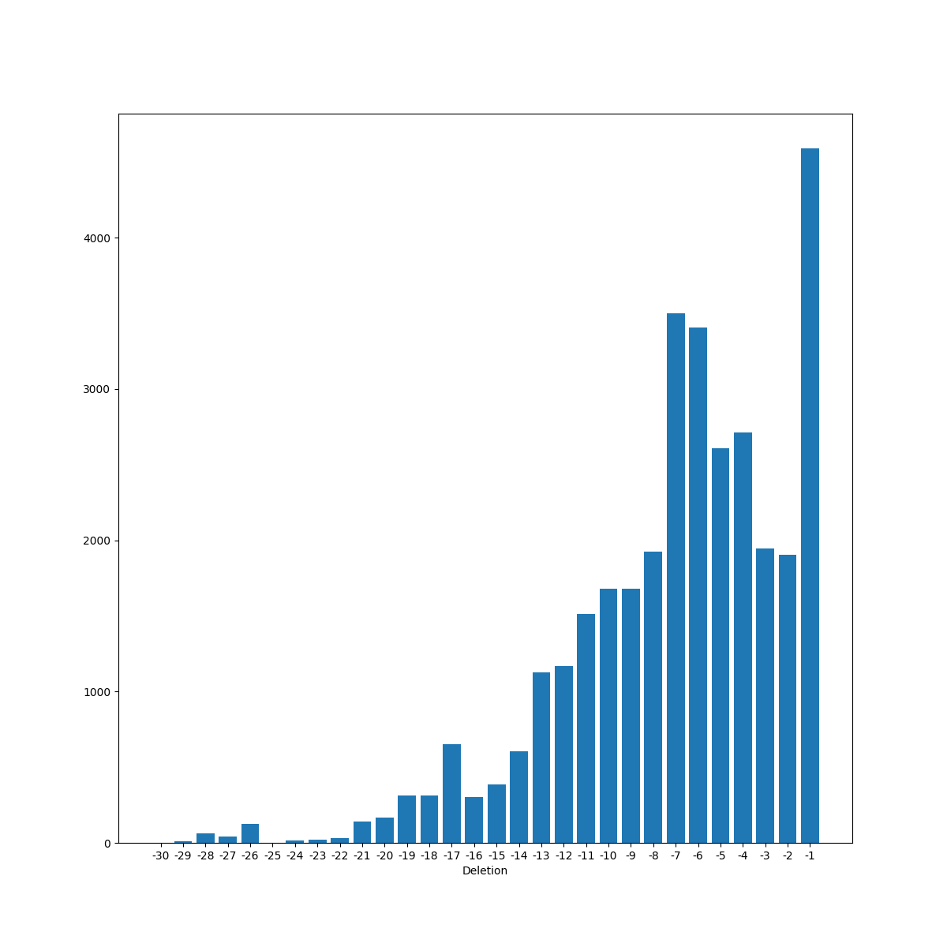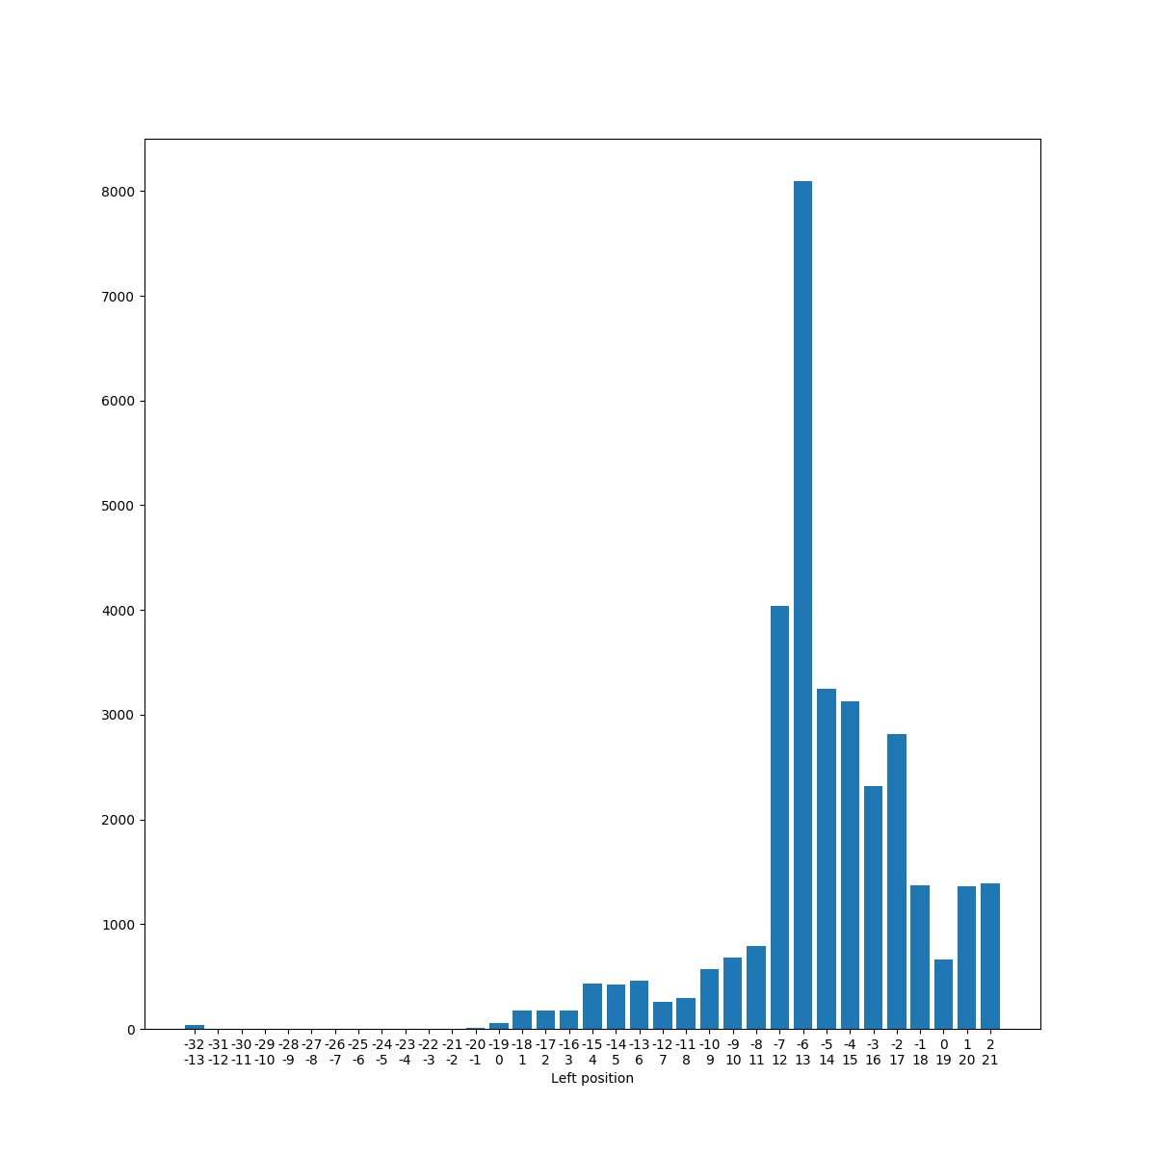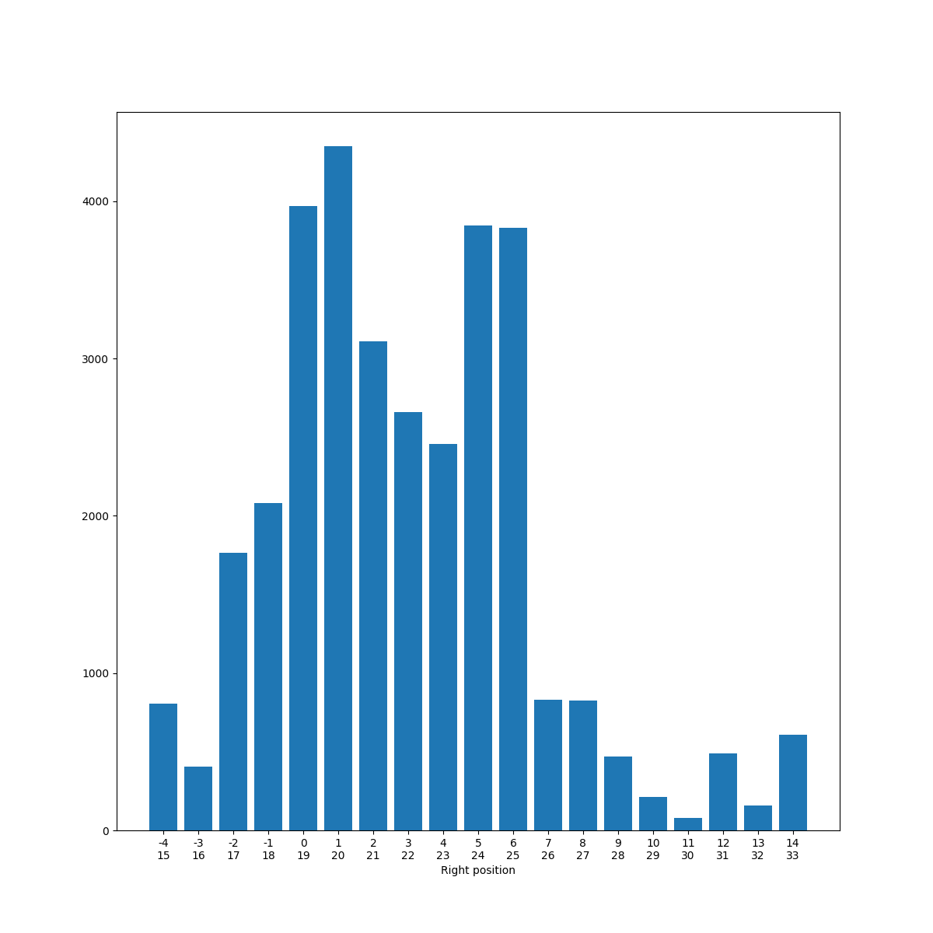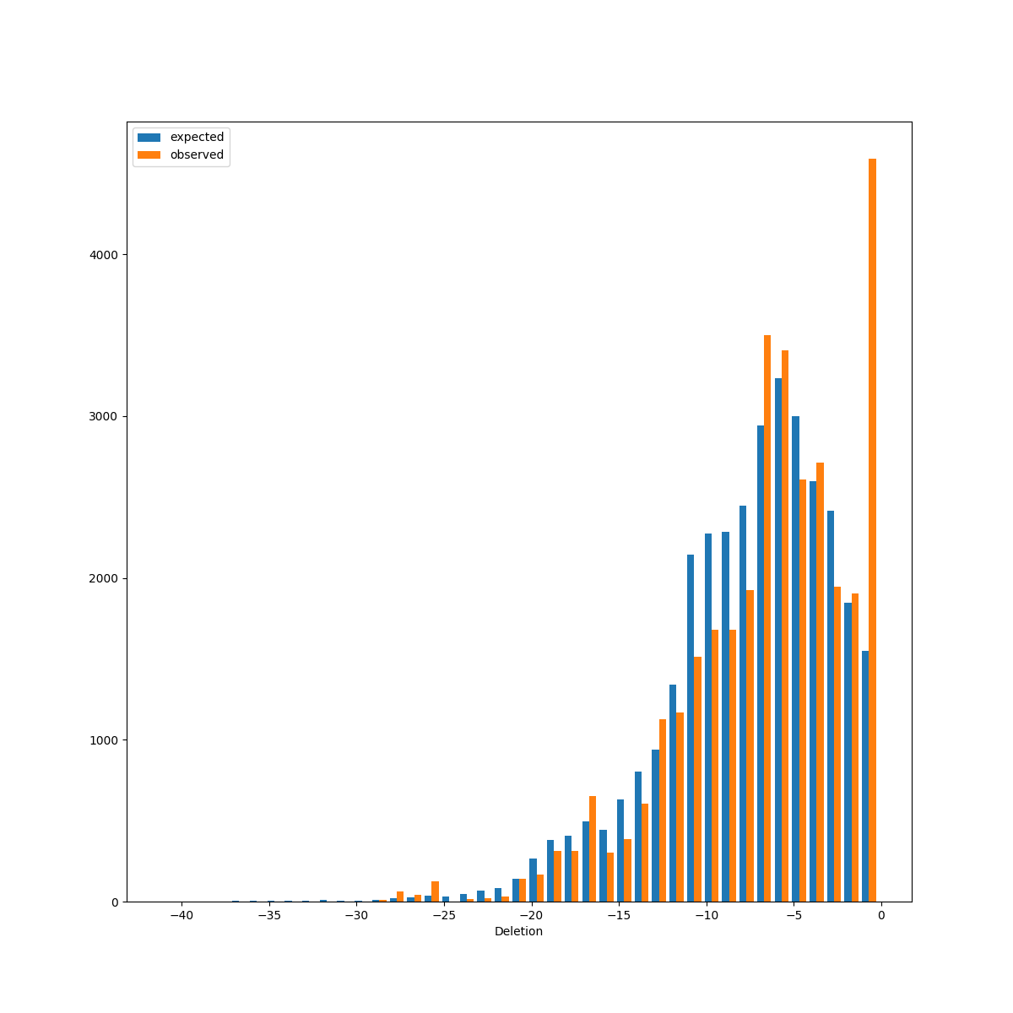

all_indel_microhomology_run.py
Finds microhomologies of all lengths for each of the guide sequences (normal, random or permuted) and matches these with the deletions. For the random and permuted options the files are created.
Inputs: base_dir Directory to store output files
summary_indels.txt Summary file of all indels
guides_file File listing all guides with read count (not needed if random option is chosen)
normal_random_permuted(optional) 0: normal, 1: permuted, 2: random (default = 0) (and permuted/random options may not be useful).

Outputs: all_microhomologies.txt Gives all microhomologies found across all of the guides
673 AGTGTTTCCTACGTAATTACATA 98 T 28 2 30
Guide number Guide sequence Read count Microhomology Distance between First position Second position

all_microhomologies_matched.txt As file above but also matches with indels
1117 GGGCGAGGAACAACGACGACCTC 285 G 23 5 28 -- D8_L-1R8,D27_L-18C4R14,D20_L-9C1R13,D6_L-7C2R2
1117 GGGCGAGGAACAACGACGACCTC 285 G 27 5 32 D27_L-18C4R14 D8_L-1R8,D27_L-18C4R14,D20_L-9C1R13,D6_L-7C2R2
Guide number Guide sequence Read count Microhomology Distance between First position Second position Indel matched All indels

indels_associated.txt All indels with all possible microhomologies associated with it
indels_associated_condensed.txt As file above but keeping only the longest microhomology
1227 0.0512820512821 D12_L-6C2R9 CT 12 17 29
1228 0.415730337079 D5_L-1I2C2R5 - - - -
Guide number Percent occurred Indel Microhomology Distance between First position Second position

deletions_repeats_all_positions_and_lengths.py
For each deletion length it finds the proportion of deletions of this length which may be associated with each length of repeat or microhomology in the target sequence and plots a scatter plot with this information as well as regression lines showing how the relationship varies with the length of the repeat. This currently does not filter the guides to ensure that the read count was over 100.
Inputs base_dir Base directory where output is being stored. This should contain the indels_associated_file from running all_indel_microhomology_run.py.
Outputs: mh_len_{}_del_len Scatter plots for lengths of repeat sections 0 to 8 with regression lines also plotted.
mh_proportions_del_len Regression lines for each of the microhomology lengths and proportion of deletions
Plots expected:
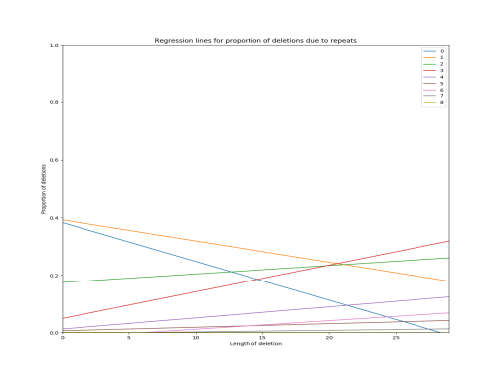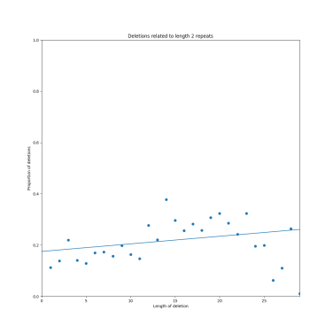

Insertions:

example_reads_for_indel.py
Finds an example of a read for each indel and oligo indel pair for all of the guides.
Inputs: base_dir Base directory where all output will be stored. Should already contain a folder for mapped files, summary file of indels
indelmap_output_dir Path to the directory where the mapped text files are stored
indelmap_output_name Example of base region in the name of the mapped files e.g. for "4_indelmap_output_32.txt", give "4_indelmap_output".
reads_dir (not currently in argument parser) Path to the directory where the fastq files separated per guide are located
Outputs: example_reads_indels.txt File containing the indel, indel and mismatch in the oligo and an example of the sequence associated.
@@@Cpf1_Oligo1
- -_D1S-45 TGTAGATAACTACGAGCGCTTTGTGCCCCGTTTTTTAGACGAGATGTACGGATTTAAACTACGAGCGCTTTGTGCCCCGAGCTTGGCGTAACTAGATCT
- -_- TGTAGATAACTACGAGCGCTTTGTGCCCCGTTTTTTTAGACGAGATGTACGGATTTAAACTACGAGCGCTTTGTGCCCCGAGCTTGGCGTAACTAGATCT

output_insertions.py
Extracts all the insertions and examples of relevant reads and outputs them into a file called "all_insertions.txt", having removed the insertions that seemed to correspond to no cut.
Inputs: base_dir Base directory where output will be stored. This directory should contain "all_guides.txt" in a subdirectory "core_files", "indels_associated_condensed.txt" and "example_reads_indels.txt"
Outputs: all_insertions.txt

plot_insertions_rand.py
38 I1_L-10C1R-8 0.00263157894737 TTTACCGAAGGCCCTTGACCGTCGTGGAGCTTGGCTTAACTAGATCT \n CCGAAAGCTCTTGAGCGTCGTGGAGCTTGGCGTAACTAGATCT
guide number indel percentage read with insertion \n
target
Looks at the insertions and determines if the inserted region is within the target sequence, if it is then the position is plotted for each length of insertion, when multiple positions are possible, one is randomly chosen. A second plot showing the count of whether it is or is not in the guide is also produced.
Inputs: base_dir Base directory where output is being stored. This should contain the all_insertions_with_insert.txt file from running the above script.
Outputs: all_insertions_with_insert_condensed.txt CHECK what this file looks like
insertions_match_guide_positions.png A line plot showing the proportion of times for a particular insertion length that the inserted section started at that position in the target sequence
insertions_match_guide_not.png Bars showing the number of indels with each insertion length and a count of whether they were found in the target sequence or not.
Plots expected:
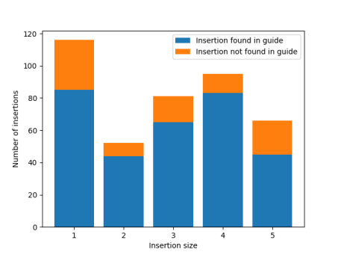

Other plots:

mean_read_number.py
Computes the mean number of reads mapped across all guides. Creates a scatter plot (indel_count_vs_guide) showing, for each indel, the number of times that it occurs and the number of guides it was found in.
Inputs: summary_indels_percent.txt
Path for indel_count_and_guides_plot
Outputs: indel_count_vs_guide
Plots expected:
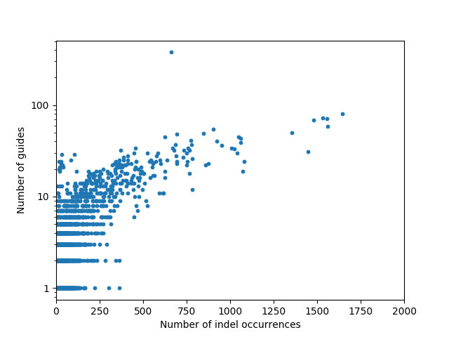

indel_frequency_vs_read_count.py
Computes the indel frequency found for guide against those reported previously. Produces plots for showing the reported and determined indel frequencies against the number of reads found for each guide (scatterplot_indel_freq_read_count_mismatch). Also, a function (split_by_activity) to split the guides into 5 groups according to their activity level, with the option to filter the guides based on the read count.
Inputs: summary_indels_percent.txt
all_guides_freq.txt File with each guide and the reported indel frequency from the paper
Outputs: scatterplot_indel_freq_read_count_mismatch.png Plot comparing the reported and determined indel frequencies against the read count for each guide
reported_against_determined_mismatch.png Scatterplot comparing the indel frequencies that were determined and reported.
Plots expected:
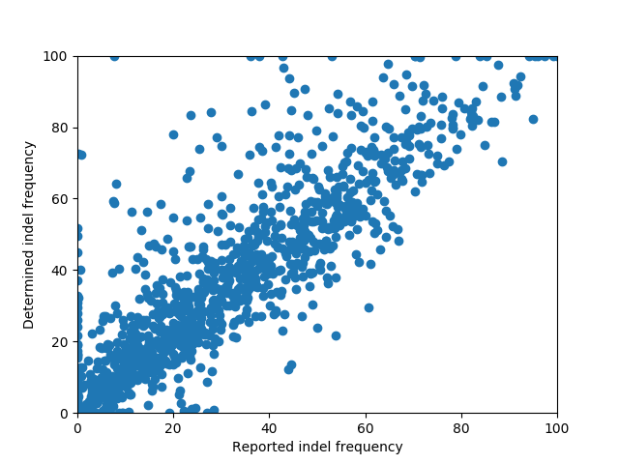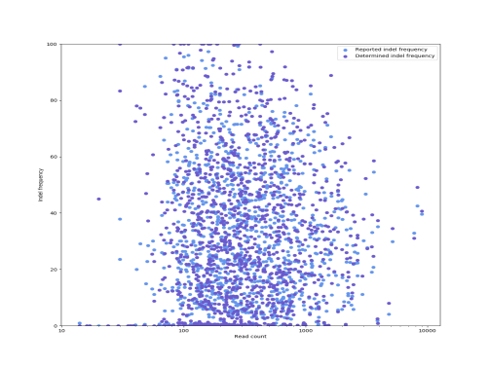

indel_lengths.py
Creates a profile of indel lengths across all guides which have a read count above the filter parameter.
Inputs: summary_indels_percent.txt
base_dir Base directory to store plots produced
filter (optional) Include only the guides which have a read count above this threshold in producing the plots (default = 100)
no_groups (optional) The number of activity groups that the guides should be split into. Give 0 to not produce the plot (default = 0)
Outputs: indel_length_split_activity.png A scatterplot showing the proportion of indels of each length seen across guides in each of the activity groups.
indel_lengths_all_height.png Plot of the distribution of all indel lengths with the height of the bar corresponding to no net change in length shown. Also, if no_groups is given, separate such plots for each group are given.
indel_lengths_truncated.png Same plot as above with a smaller limit on the vertical scale to show the differences between frequencies of the various indel lengths. Again, if no_groups is given, separate plots for each group is given.

Plots expected:
